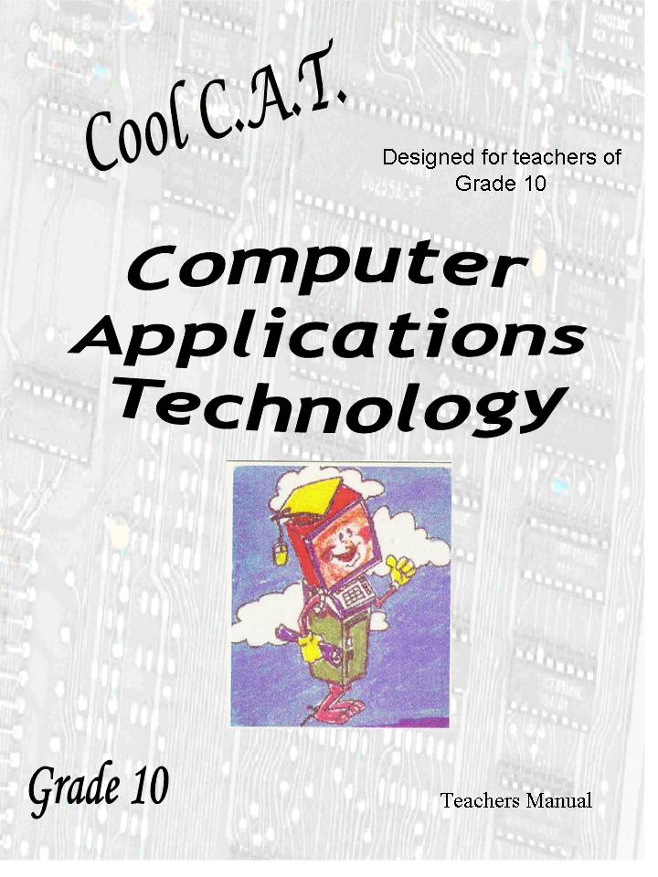

© umSinsi Press 2011
Text © Vera Castleman 2011
Illustrations © 2011
Second Edition

No part of this book may be reproduced
or transmitted in any form or by any means,
electronic, electrostatic, magnetic tape or mechanical,
including photocopying, recording
or by any information storage and retrieval system,
without permission in writing
from the publisher.



Published by
umSinsi Press
PO Box 28129
MALVERN
4055
KwaZulu-Natal
South Africa
www.umsinsi.com
ISBN 978-1-4309-0336-9

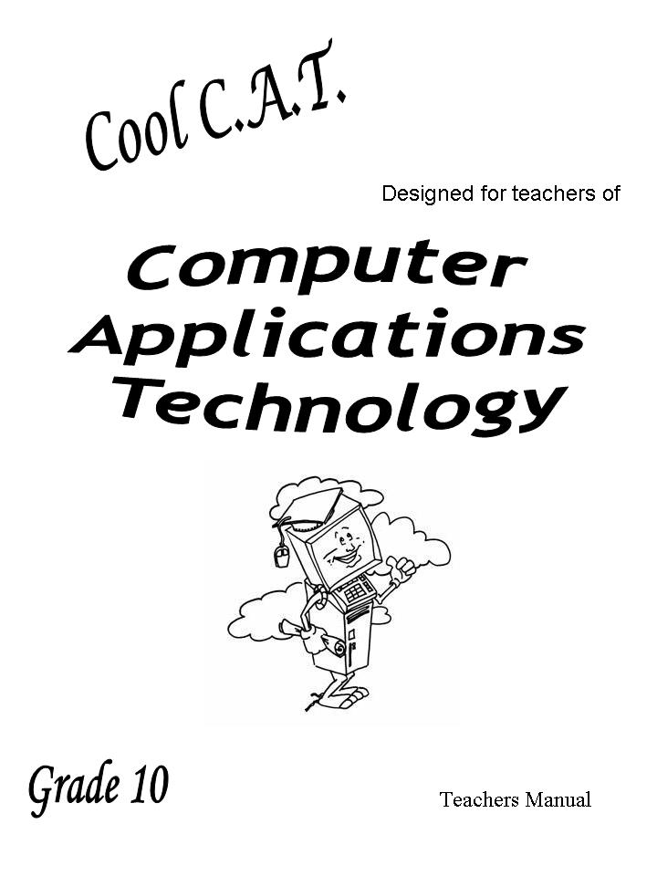
Table of Contents
Introduction 5
Note to teachers 5
What qualities do you look for in a CAT learner? 7
What qualities should you, the CAT teacher have? 7
Teaching Strategies 7
Become green in your computer venue 8
What is C.A.T? 8
Aims of CAT 8
Resources 8
Assessment: 9
Conclusion 10
The Internet 10



Introduction

Note to teachers
At the beginning of the year you will receive the “White Book” which is now usually given in electronic form. Refer to it at all times. It is a wealth of information!
In this section I will be giving ideas on how to deal with various sections and situations.

A chat
This teacher’s guide will hopefully be a pillar of strength for you. I know that all learning areas have their own set of problems but the problems facing a CAT or IT teacher is very unique.
- Usually there is only one of you in the school. The language teacher has a good support group in the school. You are usually alone. You cannot share the marking with anyone – you cannot bounce lesson ideas off anyone. Most of the teachers in the school are hardly computer literate and do not understand the many strange issues you have to deal with.
- You have a room full of inanimate objects that at times definitely seem to have a life of their own. It will seem that just as you need them the most, they will not co-operate.
- You have a class of learners who have taken to ICT from the time of birth! By age two they were using the TV remote, by age 5 computer games were in. They think they know it all. It can be very intimidating for you! You need to let it work for you!
- You will also have the few totally disadvantaged children – children who come from the other side of the digital divide. These children start off nervous. They are worried about damaging the equipment and losing information. They need to be nurtured and assured. With education comes understanding.

Teaching ICT
The modern technological times can be a little bit daunting! It seems that every time we turn around, we see a new discovery or an upgrade. We bought our computer system last month and now there is a better one on the market. It is getting so that every morning when I wake up, I wonder what new innovation I will hear about today! The new ideas and devices create a stimulating environment. You are teaching in a subject area that is continually changing. Health experts say that the best way to keep young is to keep on learning. So we are in the right subject area!
With ICT you are never in the position to say–
- I have now learned all there is to know. A new invention is happening NOW!
- I know more than my learners – there are some who know a lot, maybe not in the same depth but they are very comfortable with technology and are not afraid to experiment
- I used those notes last year I don’t have time to upgrade them so I will just use them today – much of the content will be outdated!
As I browse the Internet a new technology will catch my eye but the first hyperlink will lead me somewhere else and before I know it I am in Techno overload. So how do I deal with this? I cheat a bit. I make it a task for the class to find out about one item each and then report back. They have enquiring minds; you are allowing them to use the Internet and in doing so they will broaden their knowledge, the class’s knowledge and yours!
What do you do if a learner asks you something and you don’t know the answer?
- Try to bluff your way out? Don’t do it. They will know that you are hedging and will wonder what other gaps in your knowledge you are hiding.
- Be honest and say something like - “Wow – you caught me! I don’t know. Where did you hear about it? Won’t you get some information so that we can share it with the class?” As long as you don’t show too many gaps in your knowledge they will respect you for owning up and will be delighted to have taught you something.
Teachers have lots of areas of responsibility:
- Class teacher,
- Maths teacher to one class
- CAT teacher to grade 10 (and probably grade 11 and 12 as well)
- Marking
- Preparation
- Setting of tests and exams.
You just do not have the time to spend on one class. We do not live in an ideal world so let’s try to make it as ideal as possible. Let the class dig out the facts and lead you to it when they have done the hard work.
- They will enjoy it.
- What they learn this way will be remembered
- There will be a bit of one-upmanship (my topic was better that yours!)
- AND you will be up there with them in this knowledge. And strangely they will respect you for telling them the truth!
I have learnt a lot from my learners

Activities to stimulate research on new technologies
- Walk into the class and announce. “I would love to have a Kindle”. Challenged them to find out what a Kindle is.
- On a Friday ask everyone to bring an ICT article from a newspaper that they saw over the weekend. On Monday have a discussion. Some will not participate but they lost out!
- Play a video clip as they are coming in to class. They will be intrigued. When I did this, they settled quickly and asked me to play it again. If you receive e-mails that have anything to do with technology – save them. This will stimulated questions and interest.
- Do a treasure hunt – Give each learner a letter. They need to find some item in technology that starts with that letter – learn about it and share with the class.
With these activities I often get asked “Is this for marks?” My answer is “No it is for education BUT it may come up in a test or exam!” We need to stimulate the learners to want to learn for the sake of knowing – only that way will our ICT learners become life long learners!

What qualities do you look for in a CAT learner?
There is no real hard and fast rule about this. Think about the following points that I personally see as advantageous and make your own list.
A pupil should
- Be interested in Technology
- Be inquisitive about how things function.
- Be creative
- Be ambitious to improve
- Want to be an efficient computer user
- Be open minded
- Think Logically
- Have a good work ethic.
The CAT learner will
- be trained to understand the concepts of ICT
- use the Internet responsibly
- develop techniques to research information and draw his/her own conclusions
- use appropriate software to collate his/her findings
- develop techniques to communicate his/her findings to an audience
- learn to use ICT’s responsibly.

What qualities should you, the CAT teacher have?
Once you have decided what qualities you would like your learners to have and tied that together with what you expect from a CAT learner, think of your own qualities and see if you can get them to work for you.

Teaching Strategies
I am not going to lecture you on your strategies. Teaching is a very personal thing. If you are the “actor” your teaching style will not be the same as the teaching style of the “academic” or the “clown”. There are a few pointers I would like to mention though:
- Be confident as you present your lesson. Today’s youth are quick to see a chip in your “armour” and quicker to take advantage.
- Listen to the learners, they can teach you a lot.
- Vary the way you greet the class. Get their attention.
The topics in this course are integrated. Each section is interdependent. Hardware and Software need to coexist. One is no good without the other.
I seldom ask my class to do written work with pen and paper. At the beginning it is a bit painful as they take so long to type but it does pay off in the end. Typing their work is a much more meaningful typing exercise than always using a typing tutor.

Become green in your computer venue
One advantage of using computers is that we could positively contribute to the carbon footprint issues. Computers were supposed to save paper but I think more shredding takes place now than previously.
E-mail tasks to the learners and they e-mail their tasks back to you. Give out the minimum of notes - e-mail most notes to them.
Develop Presentations and encourage them to take the presentations that you use for teaching various sections. (a presentation on each section of the book is included on this CD)
Get them to share their research on the small topics given to them.
All of these techniques teach them management of the Computer equipment and the concepts of e-mailing. One of your first lessons in Grade 10 should be to teach them how to send and receive e-mails.

What is C.A.T?
CAT stands for Computer Applications Technology. As mentioned before the study of computers leads to an integrated course because all components meld together to form a whole. IN CAT we lead the learner to be able to use all components of the course in such way as to make them a viable employee in our modern world. (Please see your Teacher’s white book for a detailed explanation of the Education Department’s philosophy)

Aims of CAT
My personal aim is to
- Develop a learner’s enquiring mind.
- Develop an enthusiasm for the subject
- Make them confident to use ICT in all relevant situations.
(Please see your Teacher’s white book for a detailed explanation of the Education Department’s philosophy)

Resources
- A fully functional computer room with enough computers in the class so that no learner has to share. There should be two spares in case of breakdowns.
- The computer venue needs to be secure; burglar guards and security gates are essential.
- A networked environment
- An internet connection is vital.
- Each learner should have their own e-mail account.
- Fully licensed software.
- A data projector
- At least one networked printer.
(Please see your Teacher’s white book for a detailed explanation of the Education Department’s philosophy)

Group work
There are many ways that you can use group work. You have probably been doing it for years but I may have a trick or two that you haven’t tried. I usually do not have more than 3 in group. With more in a group you will usually get a hanger on! I never use the same grouping twice in a row.
The first session in grade 10 let them choose their own groups to establish a comfort zone. Then you can use one of the following ways:

Lucky dip
Make numbers or use playing cards. Everyone with the same number must move to the same area of the room.

Peer leadership
Rank the learners according to their latest results. The top learners will lead a group and then going down the list each will get another member and then the last member.

Ranked grouping
This is used to challenge all. The top 3 members work together, then the next 3 and so on. This will give the top learners stimulation.

Random grouping
This can be done as they sit in the room or you can use an excel spreadsheet to randomise a position. Let’s say you have 21 in the class. You want 3 in a group so you get them to count off in 7’s. All the ones together etc.
I’m sure you will have many other methods. If you care to share please contact me!

Suggestions:
The same topic could be given to all groups. Points could be awarded: 5 if no one else had the topic, 0 if not original. 0 to 5 for substantiation. Winning group gets a sweet?
Each group gets a different topic. Let them vote for the winning group – they may surprise you!

Assessment:
All work done needs to be assessed. Before you can do a formal assessment the learner has to have a clear idea of what is expected in the task. Sometimes I am unilateral and I give the rubric to them. An interesting experiment is to give the topic and let them build up the rubric! You will need to lead them to some of the essential points but they come up with some surprisingly good ideas!

Assessment techniques:

Informal:
Walking around and checking that work is being done. Chatting to the learners to ensure that they understand the topic and helping to steer them in the right direction.

Personal Assessment
This is an interesting exercise. Allow each learner to assess their own work. This can be done in a verbal interview or they could submit a mark on their script – following the rubric!

Peer Assessment
This is useful for any work that is presented to the class. As each presentation concludes the class gives a mark. The learner may also submit a mark for themselves!

Formal:
This constitutes the criteria as laid down by the Education Department.

Conclusion
By the end of the grade 10 year, my learners have presented at least 4 topics to the class. The difference between the first presentation and the last presentation indicates their individual growth and confidence.
They will learn a lot from each other:
- Facts that may not be strictly within the scope of the course but will help them grow as an ITC learner.
- Presentation techniques that they enjoy and can implement in their own future presentations
I keep all my notes and presentations on a computer that is freely accessible to them. They may use the files to help them study for exams.

The Internet
- Encourage the use of the Internet as a primary source of reference.
- Show how easy it is to see if they have copied and pasted text from the Internet. (Select a passage, copy it and paste it in a Google search)
- 4 main words/phrases for summaries
  - READ
  - UNDERSTAND
  - SELECT main points
  - WRITE in own words
- Make sure that they understand that Google is a Search Engine and not a source of information. It merely points the way to the information. It hyperlinks to the web site to use as a reference in a Bibliography. At the start of the year I will subtract 1 mark if Google is used as a reference. Term 2 they will lose all marks for the Bibliography. Hopefully by the time their Practical project is complete they will have learnt!
- Encourage them to check facts they find on the Internet. Some sites do not include valid references. You cannot believe all that you read. Some sites are encouraging you to buy their products so obviously the picture that they paint will be glamorous!
- And finally watch the sites that they use on the Internet.
